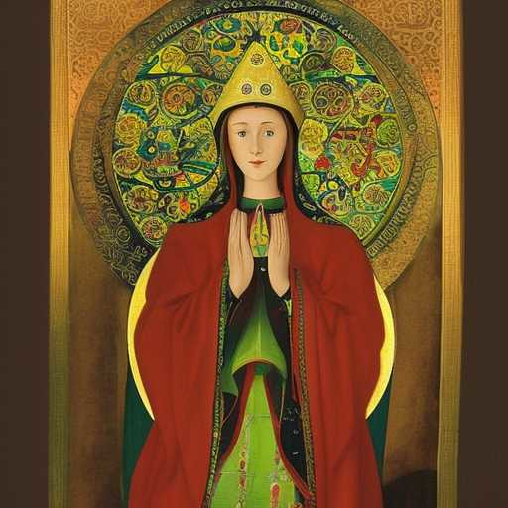
A MYSTIC CONVERSATION WITH ST. HILDEGARD VON BINGEN

I am One of The Four Infallible Queens
Tell them that we knew about the mere men with big hats long, long ago We dared to stand up to them
And they made us Queens for it
Tell them
Tell the young women this
Tell them also, that the True Divine Feminine Strength stands,
not to prove anything
It simply stands

Men want an equal
Not a victim
Not a superior
Remind them
They have forgotten

